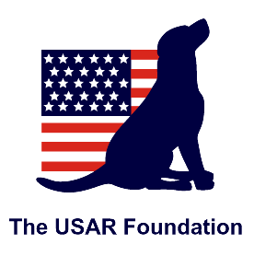
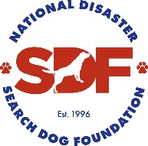
Application for Certification Evaluation Live Find
TN-TF1 USAR Foundation: 145 Feathers Chapel Dr, Somerville, TN 38068
The TN-TF1 USAR Foundation is hosting open Certification Evaluations* for Live-Find (LF) disaster search & rescue teams at their Memphis, TN training site June 26-28, 2020. This SDF-sponsored event is open to all teams with an affiliation to established organizations. Priority will be given to SUSAR teams requiring certification or recertification as deployable assets for their task force (Task Force approval required). Remaining spaces will be open to other teams, including FEMA teams that would like to use this exercise as a training and/or mock testing.
*Tests are SUSAR sanctioned, as well as EMAC & EMAP compliant. This is NOT a FEMA Certification Evaluation and teams testing will not qualify to deploy with a FEMA task force.

Applications will only be approved once completed in full, with task force approval, and after confirmation of your status on the task force. There are eight (8) spots available for each test and spots will be reserved in the order in which applications are received. You will be notified by email if you have secured a spot, as well as your test time.

Once completed, submit this form to SDF Program Manager, Kate Horwick, at kate@searchdogfoundation.org.

CHECK TESTS THAT APPLY: | ☐ Type I/CE – Friday, June 26, 2020 | ☐ Type I/CE – Saturday, June 27, 2020
Recert: ☐ Yes ☐ No | Number of prior attempts: | Date of Type II/FSA-LF:
Applicant’s Personal Information
Name: Task Force:
Address:
City: State: Zip:
Phone: Email:
Emergency Contact: Emergency Contact Phone:
Canine Information
Name: Breed:
DOB:
My canine and I are physically sound and under no restrictions. I understand and accept that the decisions of the evaluators are final. I understand that though FEMA evaluators are being used, this is not an official FEMA Certification Evaluation, and that the results of this exercise will not result in FEMA Certification. I affirm that I have read, understand and will abide by the FEMA/US&R Code of Conduct and understand that violation of said rules and Code of Conduct may result in loss of certifications, loss of evaluator status and/or referral to the appropriate authorities. I further affirm that I understand that abuse of the canine is not permitted at any time.

Applicant Signature: Date:
Task Force Approval
Task Force Title:
Name:
Signature:
Date:
Email:
Phone:

